Influencer Dashboards For Digital Marketing

A report submitted for the course of
Application Development - R Explore
II B. Tech I Semester
by
K. Sri Nandini - 2211CS030092
A. Aparna - 2211CS030100
M. Sandeepthi Chaitran - 2211CS030101
R. Bhavana - 2211CS030142

Under the esteemed guidance of

Mr.V.Rupesh
(Asst.professor)



Department of Data Science

Malla Reddy Univeristy
Maisammaguda, Dulapally,
Hyderabad, Telangana 500100
www.mallareddyuniversity.ac.in
2023-24

DATA SCIENCE


CERTIFICATE

This is to certify that this bonafide record of the Application Development entitled Title submitted by Ms. K.Sri Nandini(2211CS030092), Ms. A.Aparna(2211CS030100), Ms. M.Sandeepthi chaitran(2211CS030101), Ms.R.Bhavana (2211CS030142) of IIyear I semester to the Malla Reddy University, Hyderabad. This bonafide record of work carried out by us under the guidance of our supervision. The contents of this report, in full or in parts, have not been submitted to any other Organization for the award of any Degree.

Internal Guide:  Mr.V.Rupesh  (Asst.professor) |  | Head of the Department  Dr.GS Naveen Kumar
 | External Examiner

Date:

ABSTRACT

In the era of online shopping and social media dominance, digital marketing plays a vital role to endorse and promote products, making it essential for brands and marketers to understand and leverage influencer performance metrics. This project introduces an interactive dashboard designed for comprehensive analysis and visualization of Instagram influencer data. The proposed dashboard aims to provide a user-friendly interface that enables users to explore and derive actionable insights from Instagram influencer data. Built using R programming language these dashboards are easy to understand and help you analyze the complete profile and activities of the influencers, which will help you make informed decisions about which influencer is the best for your brand. From our dashboards the marketer will be able to get an idea about the influencer’s followers, number of likes on their posts, engagement rate of their followers, avg age group of the users, country of origin of the influencer and many more. These dashboards are designed in a way that would respect the privacy of both the influencer and the followers.

CONTENTS

Certificate |  | I
Abstract |  | II
Contents |  | III
List of Figures |  | IV
List of Tables |  | VI
Abbreviations |  | VII
Chapter 1 | Introduction | 9
 | 1.1 Problem Statement | 9
 | 1.2 Key features | 10
 | 1.3 Dataset samples | 11
Chapter 2 | Review of Relevant Literature | 13
Chapter 3 | Methodology | 14
Chapter 4 | Results and Discussions | 15
Chapter 5 | Conclusions and Future Scope of Study | 17
References |  | 18
Appendix A : Sample Source Code |  | 19

LIST OF FIGURES

Figure | Title | Page
1 | Facebook and Twitter plots | 14
2 | YouTube data plots | 15
3  4  5 | Instagram data plots  User data plots  Growth of platforms through years | 15  16  16

LIST OF TABLES

Table | Title | Page
1.1 | Sample of Instagram data set | 11
1.2 | Sample of Facebook data set | 11
1.3 | Sample of YouTube data set | 12

LIST OF ABBREVIATIONS

DVR Data visualization in R
DT Data Tables
HC High Charter
Chapter 1 : Introduction

1.Introduction

In the dynamic world of digital marketing, understanding and measuring the efficacy of influencer campaigns is crucial. Our Influencer Dashboards have been meticulously crafted to empower digital marketers with real-time insights, comprehensive analytics, and strategic tools that elevate influencer marketing to new heights. Our dashboards give a complete overall view about influencers in different platforms. Not only about the influencers but we have also got some insights about the audience on those platforms.
Imagine having a centralized platform where every engagement, click, and conversion driven by influencers is not only tracked but analysed to provide actionable data. The Influencer Dashboards go beyond the surface, offering a deep dive into campaign performance, audience demographics, and the overall impact on brand visibility and engagement. The Influencer Dashboards are meticulously crafted to empower digital marketers in navigating the complexities of influencer marketing successfully.
As the digital marketing landscape evolves, our Influencer Dashboards project stands as a beacon of innovation, providing marketers with the tools they need to navigate the intricacies of influencer marketing successfully. Join us in reshaping the future of digital marketing, where data-driven decisions and strategic collaborations redefine the way brands connect with their audiences through influencers. Welcome to a new era of influencer marketing excellence.

Navigate through a user-friendly interface designed for marketers of all levels of expertise. Dive into real-time analytics that unveil trends, identify key performance indicators, and guide strategic decisions. Our goal is to empower digital marketers to make informed choices, optimize campaigns on the fly, and maximize the return on investment from influencer partnerships.

The introduction makes it clear that the Influencer Dashboards are purpose-built to meet the needs of digital marketers. It emphasizes that these dashboards are not just tools but a comprehensive solution that empowers marketers to navigate the complexities of influencer marketing successfully.

So, whether you are a seasoned marketer or a digital marketing enthusiast looking to expand your knowledge, our Influencer Dashboards project offers a unique opportunity to enhance your skills and contribute to the success of influencer marketing campaigns across the globe.
1.1 Problem Statement
In the rapidly evolving landscape of digital marketing, brands are increasingly leveraging influencers to connect with their target audiences. However, marketers face a significant challenge in effectively understanding, measuring, and optimizing the impact of influencer campaigns. The lack of a centralized and comprehensive platform results in a fragmented approach to influencer marketing analytics, making it difficult for marketers to make data-driven decisions and maximize the return on investment. There is a critical need for a solution that consolidates real-time insights, comprehensive analytics, and strategic tools into a unified Influencer Dashboard, empowering marketers to navigate the complexities of influencer marketing with precision and achieve optimal campaign outcomes. This problem statement underscores the demand for a centralized, data-driven platform that addresses the current gaps in influencer campaign measurement and optimization.

Influencer Dashboards represent a significant leap forward in the field of digital marketing, offering a powerful and comprehensive solution for measuring the effectiveness of influencer marketing campaigns. By providing real-time insights, comprehensive analytics, and strategic tools, these dashboards empower marketers to make informed decisions, optimize their campaigns, and maximize their return on investment. As the digital marketing landscape continues to evolve, Influencer Dashboards will undoubtedly play a pivotal role in shaping the future of influencer marketing.

1.2 Key features
Our “Influencer Dashboards for Digital marketing” offer a wide range of features for the users some of them are listed below
Real-time insights: Influencer Dashboards enable marketers to stay updated with the latest trends and developments in different social media platforms and content creaters, allowing them to make informed decisions quickly.

Comprehensive analytics: By providing in-depth analytics and data visualization tools, These Influencer Dashboards help marketers gain deep insights into their influencer activity data, strategies, enabling them to measure their effectiveness and optimize their choice of influencer accordingly.

Strategic tools: These dashboards offer a wide range of strategic tools and features, empowering marketers to make data-driven decisions and elevate their influencer marketing campaigns to new heights.

Performance optimization: Utilize data-driven strategies and tactics to optimize the performance of your influencer, to maximize the potential to improve sales and increase brand awareness among people.

Follower Growth Trends: Display trends in follower growth over time to help identify periods of significant audience expansion or contraction.

Top Performing Platforms: Identify which social media platforms are most effective for the influencer, helping marketers optimize platform-specific strategies.

Engagement Rate Calculation: Automatically calculate and display the engagement rate to provide a standardized measure of interaction relative to the size of the influencer's audience.

Audience Demographics: Offer insights into the demographics of the influencer's audience, such as age, gender, location, and interests.

1.3 Dataset samples

Rank of the Influencer | Username of the Instagrammer | Influence score of the users | Number of posts they have made so far | Number of followers of the user | Average likes on instagrammer posts
1 | cristiano | 92 | 3.3k | 608.5 | 8.7m
2 | selenagomez | 93 | 1.8k | 342.7 | 6.2m
3 | arianagrande | 92 | 5.0k | 327.7 | 3.7m
4 | justinbieber | 91 | 7.4k | 254.5 | 1.9m
5 | virat.kohli | 87 | 1.4k | 211.8 | 3.5m
6 | priyankachopra | 85 | 3.6k | 81.1 | 1.6m
7 | shraddhakapoor | 81 | 1.9k | 73.9 | 1.6m
8 | victoriassecret | 88 | 2.9k | 73.2 | 147.0k
9 | taylorswift | 91 | 0.53k | 222.2 | 2.4m
10 | Shawn Mendes | 84 | 2.5k | 75.6 | 1.3m
Table1.1: sample of Instagram data set

Name | Followers | Reach | Likes per post | Comments | Average engagement rate
Taylor Swift | 526.9M | 138.6M | 36.8K | 2.9K | 0.05%
Kapil Sharma | 97.7M | 21.4M | 126.9K | 3.1K | 0.39%
James Rodriguez | 112.1M | 34.6M | 234K | 3.9K | 0.66%
Virat Kohli | 344.2M | 49.9M | 171.4K | 3.2K | 0.34%
NJ | 361.6M | 59.1M | 60.9K | 2.3K | 0.07%
Narendra Modi | 211.7M | 109.7M | 78.7K | 7.3K | 0.18%
Justin Bieber | 594.1M | 78.5M | 113.5K | 4.4K | 0.13%
Badgalriri | 152.6M | 80.9M | 36.4K | 1.2K | 0.04%
Table 1.2: sample of Facebook data set

Name | Followers | Reach | Likes per post | Comments | Average engagement rate
Taylor Swift | 526.9M | 138.6M | 36.8K | 2.9K | 0.05%
Kapil Sharma | 97.7M | 21.4M | 126.9K | 3.1K | 0.39%
James Rodriguez | 112.1M | 34.6M | 234K | 3.9K | 0.66%
Virat Kohli | 344.2M | 49.9M | 171.4K | 3.2K | 0.34%
NJ | 361.6M | 59.1M | 60.9K | 2.3K | 0.07%
Narendra Modi | 211.7M | 109.7M | 78.7K | 7.3K | 0.18%
Justin Bieber | 594.1M | 78.5M | 113.5K | 4.4K | 0.13%
Badgalriri | 152.6M | 80.9M | 36.4K | 1.2K | 0.04%
Cristiano Ronaldo | 886M | 99.5M | 415.7K | 11.1K | 0.26%
Salman Khan | 51M | 45.6M | 79.9K | 3.9K | 0.16%
Pewdiepie | 9.1M | 89.5M | 1.5k | 193k | 0.02%
Leo Messi | 116M | 101.2M | 152.2k | 6.6k | 0.14%
kajal A Kitchlu | 22M | 95.5M | 111.5k | 2.5k | 0.50%
Barack Obama | 56M | 101.1M | 75.5k | 4.9k | 0.14%
Table 1.3: sample of YouTube data set

Chapter 2 : Review of relevant literature

While working on like this where we create different plots and dashboards, it's important that we have enough knowledge about data visualization and packages used for it. So, let us have a look at relevant literature

R Markdown: The Definitive Guide: This guide provides extensive information on using R Markdown, which is fundamental to creating flex dashboards. It covers the syntax, customization options, and integration with other R packages.
Link: R Markdown: The Definitive Guide

flex dashboard Documentation: The official documentation for the flex dashboard package is a valuable resource for understanding its features, options, and examples. It covers layout design, interactive elements, and customization.
Link: flexdashboard Documentation

R Graphics Cookbook: While not specific to flex dashboards, this book provides a wealth of information on creating visualizations in R, which is crucial for effective dashboards. It covers ggplot2, plotly, and other plotting packages that can be integrated into flexdashboards.
Link: R Graphics Cookbook

Interactive Web-Based Data Visualization with R, plotly, and shiny:
This book focuses on interactive visualization using plotly and Shiny, both of which can be integrated into flexdashboards. It's a great resource if you're looking to enhance interactivity in your dashboards.
Link: Interactive Web-Based Data Visualization with R, plotly, and shiny

Chapter 3 : Methodology

Creating a dashboard using flexdashboard involves a structured methodology that includes several key steps. Here is a suggested methodology for developing a dashboard using the flexdashboard package in R:

Define Objectives and Audience: Clearly articulate the objectives of your dashboard. Understand who the primary audience is and what insights or actions they seek to derive from the dashboard.
Data Collection and Preparation: Collect and prepare the relevant data for your dashboard. Ensure that the data is clean, well-structured, and suitable for analysis.

Install Required Packages: Ensure that you have the necessary R packages installed, including flexdashboard, tidyverse, and any other packages required for specific visualizations or interactivity.

Load Data and Libraries: Load the required libraries and import the prepared dataset into your R environment.

Design the Dashboard Layout: Plan the layout of your dashboard. Use the flex_dashboard YAML header to define the structure, including title, layout, and any additional settings.

Create Visualizations: Utilize the highcharter package and other visualization libraries to create charts and graphs. Embed them in the dashboard layout.

Incorporate Markdown and Text Blocks: Use Markdown to add text blocks, headers, and explanations to your dashboard. This can provide context and guidance to users.

Test and Refine: Test the dashboard thoroughly to ensure that all visualizations and interactive elements work as intended. Gather feedback and refine the design based on user testing.

Publish or Share: Once satisfied with the dashboard, publish or share it with your intended audience. You can use platforms like RStudio Connect, ShinyApps, or export the dashboard as an HTML file.

Document the Dashboard: Provide documentation for your dashboard, including details on data sources, methodologies used, and any specific instructions for users.

This methodology provides a structured approach to creating a flexdashboard in R. Adjustments can be made based on project requirements and specific needs. Additionally, exploring the official documentation for flexdashboard and related packages will provide further insights and advanced techniques.

Chapter 4: Results and Discussions

Our flexdashboard dedicated to influencer activity provides a comprehensive analysis of key performance indicators, allowing us to gain valuable insights into the effectiveness of our influencer marketing campaigns. This section discusses the notable findings and their implications for our strategic approach.
Influencer Performance Metrics:
Engagement Trends: The dashboard reveals varying engagement trends among influencers. Notably, Influencer H consistently maintains high engagement rates, showcasing a consistent ability to capture and retain audience interest.

Post Frequency Analysis: Examining post frequency suggests a correlation between regular posting by Influencer I and sustained audience engagement. This insight prompts considerations for optimizing posting schedules across other influencers.

Result

Now let us look at our project output. We used plots and graphs to give insights about different data sets. Some of such are line plots, bar graphs, Pie charts, data tables etc. Now let us look at a few pictures of our dashboard and discuss about information we get from them.

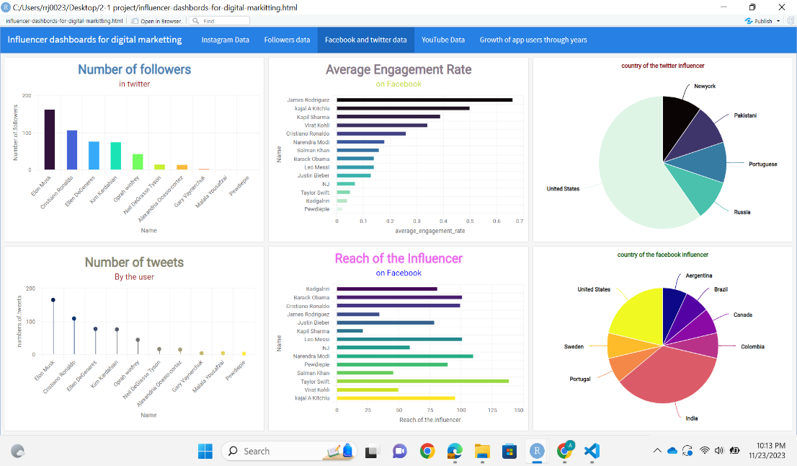

fig.1 Facebook and twitter plots

The above plots give the insights about Facebook and Twitter data of different influencer in those platforms so that we can compare them on bases of different parameters such as number of followers, number of tweets or posts, country of origin etc.

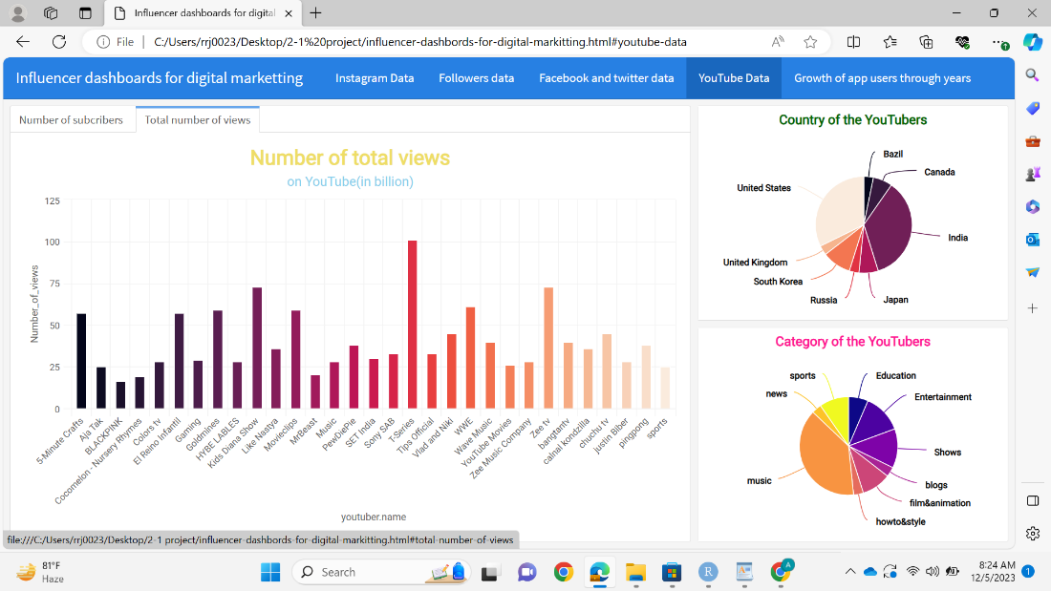
Fig2: YouTube data plots
This figure shous us some of the plots in our dashboard plotted to visualize the YouTube data set. As we can see it contains plots of countries, categories and views on different channels

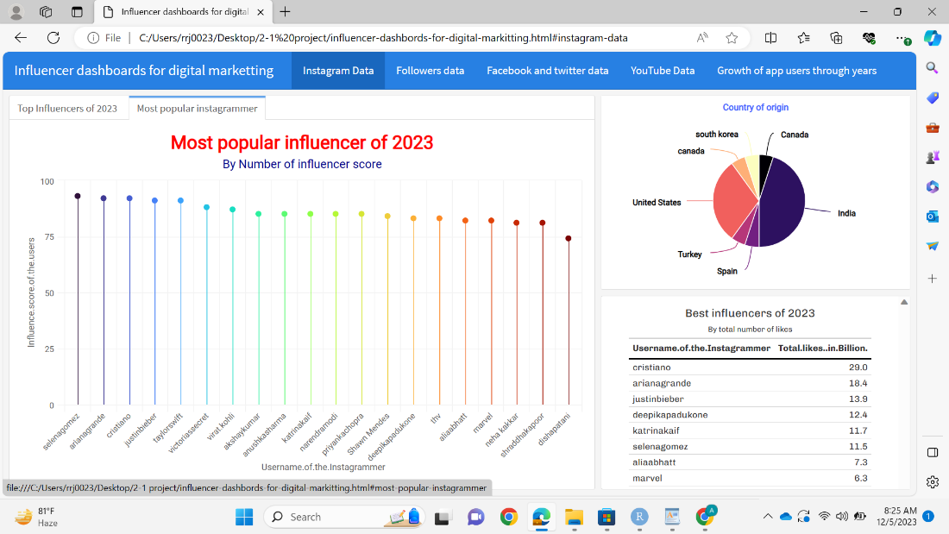
Fig3: Instagram data plots
The picture contains plots on influencer score of the influencers on Instagram and also contains a pie chart and data table showing the country and number of likes respectively
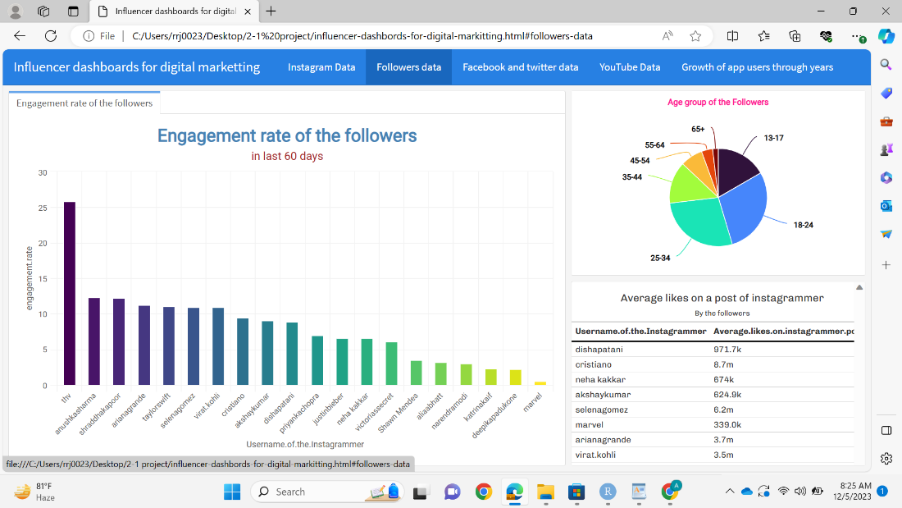
Fig4: user data plots
The above figure we have demographical information about the followers in Instagram. Such as age group and engagement rates

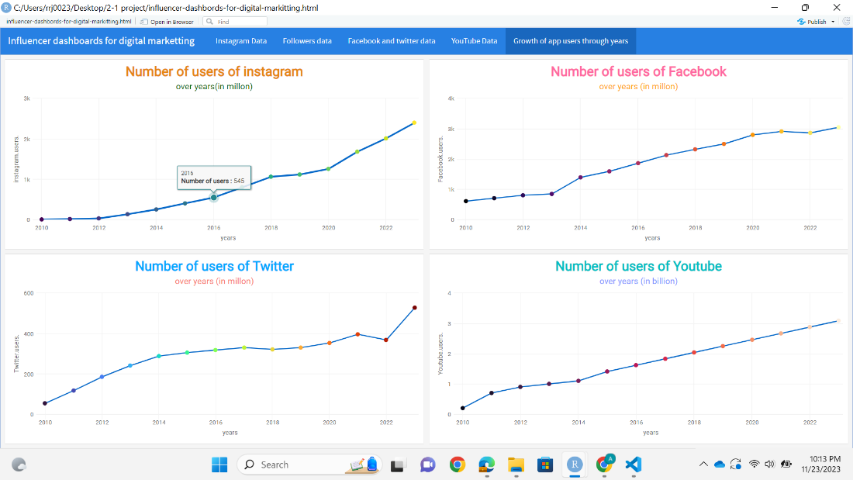
Fig5: Growth of platforms over years
These plots show the growth of different social media platforms over years from 2010 to 2023. Here we can see that YouTube has the greatest number of users in all the years

Chapter 5: Conclusion and future scope

Conclusion
In developing and analyzing our flexdashboard on influencer activity, we've unveiled a wealth of insights that serve as a compass for optimizing our influencer marketing strategy. This culmination of data-driven observations empowers us to make informed decisions, refine content strategies, and foster more impactful collaborations. Here are the key takeaways:

Influencer Performance Dynamics: Our analysis has shed light on the varying performance dynamics among influencers. Recognizing the consistent engagement prowess of certain influencers, such as [Highlight Influencer], allows us to strategically channel resources towards collaborations that deliver maximum impact.

Strategic Adjustments for Future Success: The findings from this dashboard pave the way for strategic adjustments in posting schedules, caption tonality, and content types. These adjustments aim to maximize the resonance of our influencer collaborations and foster a deeper connection with our target audience.

Audience-Centric Approach: Understanding the demographics of influencer audiences, including age distribution and geographic influence, provides a roadmap for tailoring content to specific segments. This audience-centric approach ensures our campaigns resonate authentically with diverse viewer profiles.

In conclusion, our flexdashboard serves as a beacon, guiding us towards a future where influencer marketing is not just a promotional tactic but a dynamic and strategic engagement channel. As we implement the insights gained, this dashboard remains a vital instrument for adapting to evolving trends, understanding our audience intimately, and driving the success of our influencer marketing endeavors. The journey doesn’t end here; it's a continuous evolution towards excellence in influencer collaboration and audience connection.

Future Scope:
Making it 100% accurate:
As the numbers in social media always keep changing and our database is static our dashboards are only 70-80% accurate but if we create a database that gets updated in regular intervals and we attach that database to the dashboard the accuracy of the dashboard will increase in large number
Making an influencer predictor dashboard:
We can use machine learning and deep learning concepts in the project and make predictor that tells who the right choice is for the product you want to endorse.

References:
[1] RStudio, “Flexdashboard: Easy interactive dashboards for R”
[2] flex dashboard Documentation, https://pkgs.rstudio.com/flexdashboard/
[3] R Graphics Cookbook, https://r-graphics.org/
[4] R Markdown: The Definitive Guide, https://bookdown.org/yihui/rmarkdown/

Appendix A: Sample source code
---
title: "Influencer dashboards for digital marketting"
output:
flexdashboard::flex_dashboard:
orientation: columns
vertical_layout: fill
---
```{r setup, include=FALSE}
library(flexdashboard)
library(tidyverse)
library(highcharter)
library(gt)
library(htmltools)
library(viridis)
library(dplyr)
```
```{r}
dataframe<-read.csv("dashboarddata.csv")
facebook<-read.csv("facebookdata.csv")
twitter<-read.csv("twitter.dataset.csv")
youtube<-read.csv("YouTube.csv")
growthoveryears<-read.csv("Book-5.csv")
view(youtube)
```
# Instagram Data
## Column {.tabset .tabset-fade data-width="650"}
### Top Influencers of 2023
```{r}
custom_colors <- viridis::plasma(n = 20)
dataframe %>%
group_by(Username.of.the.Instagrammer) %>%
summarise(Number.of.followers.of.the.user = sum(Number.of.followers.of.the.user)) %>%
arrange(desc(Number.of.followers.of.the.user)) %>%
head(20) %>%
hchart("column", hcaes(x = Username.of.the.Instagrammer, y = Number.of.followers.of.the.user, color = custom_colors)) %>%
hc_add_theme(hc_theme_google()) %>%
hc_tooltip(pointFormat = '<b>Number of followers: </b> {point.y} <br>') %>%
hc_title(text = "Most popular influencer of 2023",
style = list(color = "purple",fontSize = "25px", fontWeight = "bold")) %>%
hc_subtitle(text = "By Number of Followers",
style = list(color = '#001A9E',fontSize = "16px"))
```
### Most popular instagrammer
```{r}
custom_colors <- viridis::turbo(n = 20)
dataframe %>%
group_by(Username.of.the.Instagrammer) %>%
summarise(Influence.score.of.the.users = sum(Influence.score.of.the.users)) %>%
arrange(desc(Influence.score.of.the.users)) %>%
head(20) %>%
hchart("lollipop", hcaes(y = Influence.score.of.the.users,x = Username.of.the.Instagrammer, color = custom_colors)) %>%
hc_add_theme(hc_theme_google()) %>%
hc_tooltip(pointFormat = '<b>influencer score: </b> {point.y} <br>') %>%
hc_title(text = "Most popular influencer of 2023",
style = list(color = "red",fontSize = "25px", fontWeight = "bold")) %>%
hc_subtitle(text = "By Number of influencer score",
style = list(color = "darkblue",fontSize = "16px"))
```
## Column {data-width="350"}
### {.no-padding}
```{r}
coustum_colur<-viridis::magma(n=7)

dataframe %>%
group_by(country) %>%
summarise(count=n()) %>%
hchart("pie",hcaes(x=country,y=count,color=coustum_colur)) %>%
hc_add_theme(hc_theme_google()) %>%
hc_tooltip(pointFormat="<b>Proportion: </b> {point.percentage:,.2f}% ") %>%
hc_title(text="Country of origin",
style=list(color = "#4967FF",fontSize="16xp" ,fontWeight='bold'))
```
### {.no-padding}
```{r}
df2<-dataframe %>%
filter(Total.likes..in.Billion.>=1) %>%
arrange(desc(Total.likes..in.Billion.)) %>%
select(Username.of.the.Instagrammer,Total.likes..in.Billion.)

div(style='height:600px;overflow-y:scroll',gt(df2) %>%
tab_header(title=md('Best influencers of 2023'),
subtitle = md('By total number of likes')) %>%
opt_table_font(font=list(google_font('Chivo'),default_fonts())) %>%
tab_style(location=cells_column_labels(columns=everything()),
style = list(cell_borders(sides='bottom',
weight=px(2)),
cell_text(weight = 'bold'))) %>%
tab_options(table.font.size=px(12L),
table.border.top.style='none',
column_labels.border.bottom.width=2,
table_body.border.top.style='none',
data_row.padding=px(3))
)
```
# Followers data
## column {.tabset .tabset-fade data-width="650"}
### Engagement rate of the followers
```{r}
custom_colors <- viridis::viridis(n = 20)

dataframe %>%
group_by(Username.of.the.Instagrammer) %>%
summarise(engagement.rate = sum(engagement.rate)) %>%
arrange(desc(engagement.rate)) %>%
head(20) %>%
hchart("column", hcaes(x = Username.of.the.Instagrammer, y = engagement.rate, color = custom_colors)) %>%
hc_add_theme(hc_theme_google()) %>%
hc_tooltip(pointFormat = '<b>engagenent rate: </b> {point.y} <br>') %>%
hc_title(text = "Engagement rate of the followers",
style = list(color = "steelblue",fontSize = "25px", fontWeight = "bold")) %>%
hc_subtitle(text = "in last 60 days ",
style = list(color = "brown",fontSize = "16px"))

```
```{r}
dataframe1<-read.csv("Book.csv")
```
## Column {data-width="350"}
### {.no-padding}
```{r}
coustum_colur<-viridis::turbo(n=7)
dataframe1 %>%
group_by(age.group.of.the.users) %>%
summarise(percentage=n()) %>%
hchart("pie",hcaes(x=age.group.of.the.users,y = percentage,color=coustum_colur)) %>%
hc_add_theme(hc_theme_google()) %>%
hc_tooltip(pointFormat="<b>Percentage: </b> {point.percentage:,.2f}% ") %>%
hc_title(text="Age group of the Followers",
style=list(color = "deeppink",fontSize="16xp" ,fontWeight='bold'))
```
### {.no-padding}
```{r}
df2<-dataframe %>%
filter(Average.likes.on.instagrammer.posts>=1) %>%
arrange(desc(Average.likes.on.instagrammer.posts)) %>%
select(Username.of.the.Instagrammer,Average.likes.on.instagrammer.posts)
div(style='height:600px;overflow-y:scroll',gt(df2) %>%
tab_header(title=md('Average likes on a post of instagrammer'),
subtitle = md('By the followers')) %>%
opt_table_font(font=list(google_font('Chivo'),default_fonts())) %>%
tab_style(location=cells_column_labels(columns=everything()),
style = list(cell_borders(sides='bottom',
weight=px(2)),
cell_text(weight = 'bold'))) %>%
tab_options(table.font.size=px(12L),
table.border.top.style='none',
column_labels.border.bottom.width=2,
table_body.border.top.style='none',
data_row.padding=px(3))
)
```
# Facebook and twitter data
## row {data-width="350"}
### {.no-padding}
```{r}

custom_colors <- viridis::turbo(n = 10)
twitter %>%
group_by(Name) %>%
summarise(Number.of.followers = sum(Followers)) %>%
arrange(desc(Number.of.followers)) %>%
head(20) %>%
hchart("column", hcaes(x = Name, y = Number.of.followers, color = custom_colors)) %>%
hc_add_theme(hc_theme_google()) %>%
hc_tooltip(pointFormat = '<b>Number of followers: </b> {point.y} <br>') %>%
hc_title(text = "Number of followers",
style = list(color = "steelblue",fontSize = "25px", fontWeight = "bold")) %>%
hc_subtitle(text = "in twitter ",
style = list(color = "brown",fontSize = "16px"))
```
### {.no-paddind}
```{r}
custom_colors <- viridis::cividis(n = 10)
twitter %>%
group_by(Name) %>%
summarise(numbers.of.tweets = sum(Followers)) %>%
arrange(desc(numbers.of.tweets)) %>%
head(20) %>%
hchart("lollipop", hcaes(x = Name, y = numbers.of.tweets, color = custom_colors)) %>%
hc_add_theme(hc_theme_google()) %>%
hc_tooltip(pointFormat = '<b>Number of twitters: </b> {point.y} <br>') %>%
hc_title(text = " Number of tweets",
style = list(color = "#87866D",fontSize = "25px", fontWeight = "bold")) %>%
hc_subtitle(text = "By the user",
style = list(color = "brown",fontSize = "16px"))
```
## Column {data-width="350"}
### {.no-padding}
```{r}
custom_colors <- viridis::mako(n = 14)
facebook %>%
group_by(Name) %>%
summarise(average_engagement_rate = mean(Average.engagement.rate)) %>%
arrange(desc(average_engagement_rate)) %>%
head(14) %>%
hchart("bar", hcaes(x = Name, y = average_engagement_rate, color = custom_colors)) %>%
hc_add_theme(hc_theme_google()) %>%
hc_tooltip(pointFormat = '<b>Engagement Rate:</b> {point.y} <br>') %>%
hc_title(
text = "Average Engagement Rate",
style = list(color = "#878", fontSize = "25px", fontWeight = "bold")
) %>%
hc_subtitle(
text = "on Facebook",
style = list(color = "#cd3", fontSize = "16px")
)
```
### {.no-padding}
```{r}
custom_colors <- viridis::viridis(n = 14)
facebook %>%
group_by(Name) %>%
summarise(Reach.of.the.influencer = sum(Reach)) %>%
top_n(14, wt = Reach.of.the.influencer) %>%
hchart("bar", hcaes(x = Name, y = Reach.of.the.influencer, color = custom_colors)) %>%
hc_add_theme(hc_theme_google()) %>%
hc_tooltip(pointFormat = '<b>Reach of the influencer:</b> {point.y} <br>') %>%
hc_title(
text = "Reach of the Influencer",
style = list(color = "#ED68ED", fontSize = "25px", fontWeight = "bold")
) %>%
hc_subtitle(
text = "on Facebook",
style = list(color = "blue", fontSize = "16px")
)
```
## Column {data-width="350"}
### {.no-padding}
```{r}
coustum_colur<-viridis::mako(n=5)
twitter %>%
group_by(Country) %>%
summarise(count=n()) %>%
hchart("pie",hcaes(x=Country,y=count,color=coustum_colur)) %>%
hc_add_theme(hc_theme_google()) %>%
hc_tooltip(pointFormat="<b>Proportion: </b> {point.percentage:,.2f}% ") %>%
hc_title(text="country of the twitter influencer",
style=list(color = "darkred",fontSize="24xp" ,fontWeight='bold'))
```
### {.no-padding}
```{r}
coustum_colur<-viridis::plasma(n=8)
facebook %>%
group_by(Country) %>%
summarise(count=n()) %>%
hchart("pie",hcaes(x=Country,y=count,color=coustum_colur)) %>%
hc_add_theme(hc_theme_google()) %>%
hc_tooltip(pointFormat="<b>Proportion: </b> {point.percentage:,.2f}% ") %>%
hc_title(text="country of the facebook influencer",
style=list(color = "darkgreen",fontSize="24xp" ,fontWeight='bold'))

```

